**CURRICULUM VITAE**

 Poblacion, Damulog, Bukidnon

**Address**

Loylyn12@gmail.com

**Email**

0936-323-6124

**Phone**

Career objectives:

To secure a responsible career opportunity to fully utilize my training and skills, while making a significant contribution to the success of the organization.

**Additional Skills:**

1. Cooking

2. Volleyball Playing

3. Event Organizer

**Title of research/es (if any):**

**N/A**

**PROFILE**

**NAME***:* LOYLYN DE AMOR D. DALAS

**DATE OF BIRTH:** March 12, 1991

**PLACE OF BIRTH:** Damulog, Bukidnon

**GENDER:** Female

**CIVIL STATUS:** Married

**Educational Attainment**

|  |  |  |  |
| --- | --- | --- | --- |
| **Degree/s Earned**  **(*Start from the highest degree earned)*** | **Name of School & Address** | **Year Graduated** | **Academic Distinction** |
| Master of Business Management | Capitol University | CAR | N/A |
| Master of Business Management Major in Business Management | Bukidnon State University Main Campus | 2021-34 units | None |
| Earning Units of Teaching-Professional Educations | Stratford International School | 2015 | None |
| Bachelor of Science in Entrepreneurship | Bukidnon State University –Main Campus | 2012 | None |
| Old Damulog National High School | Old Damulog, Damulog, Bukidnon | 2008 | 9th Honors |
| Damulog Central Elementary School | Poblacion, Damulog, Bukidnon | 2004 | 7th Honors |

**Professional Experience**

|  |  |  |  |
| --- | --- | --- | --- |
| **Company’s Name (start from the most recent)** | **Position** | **Year** | |
| Flying V Damulog-Andromeda Fuels OPC | Station Manager | March 9,2022 | Present |
| Northern Bukidnon State College | Admin Assistant II | January 3, 2022 | March 8, 2022 |
| Northern Bukidnon State College | Clerk II | October 13, 2021 | December 31, 2021 |
| Bukidnon State University-Damulog Satellite Campus | Instructor 1 | 06/12/2018 | 6/04/21 |
| Bukidnon State University-Damulog Satellite Campus | Admin Clerk I | 04/24/2018 | 06/11/2018 |
| LGU-Damulog | Admin Clerk I | 02/02/2017 | 04/23/2018 |
| Department of Agrarian Reform | Admin Clerk I | 1/27/2014 | September 30, 2014 |
| SVI-Gensan (SM Supermarket) | Front-End Staff/ Cashier | 08/14/2013 | 1/27/2014 |
| Bright Star Industries, Inc, | Account Payable In-charge/ Finance Staff | 11/15/2012 | 05/7/2013 |
| Akromont Group of Company | Sales Associate | 05/29/2012 | 10/30/2012 |

**PROFESSIONAL DEVELOPMENT ACTIVITIES (*Start from the most recent)***

|  |  |  |  |
| --- | --- | --- | --- |
| **Title of the training/seminar** | **Sponsored Agency** | **Inclusive dates** | |
| **From** | **To** |
| Virtual Cascading of Policies and Procedure | BukSU Main | 9/23/20 | 9/23/20 |
| Inset on content development for flexible learning | BukSU Main | 7/11/20 | 7/14/20 |
| Students assessment tools for online and offline learning environment | AFTA | 7/10/20 | 7/10/20 |
| Adapting to the new normal-healthy mindset and innovation | PACSB | 7/9/20 | 7/9/20 |
| Seminar on IPCR Preparation and Performance Mgnt | BukSU HRDU | 2/27/20 | 2/27/20 |
| Seminar on TOS,Curriculum mapping &Grading System | BUKSU Main COB Department | 7/30/19 | 7/31/19 |
| Seminar-Workshop on Teaching Strategies for BA Program | BUKSU-Main BA Department & ESC | 7/18/19 | 7/18/19 |
| Seminar-workshop on Teaching Pedagogies on PE | BuKSU-Main PE Department | 7/16/19 | 7/16/19 |
| PACSB FACULTY DEVELOPMENT SEMINAR | PACSB-10 | 7/10/19 | 7/11/19 |
| Regional Folk Dance Conference and Workshop | Folk Dance Society-Region 10 | 7/5/19 | 7/7/19 |
| COBEDAPH 10- General Assembly & Conference | COBEDAPH 10 | 06/26/19 | 6/26/19 |
| PACSB FACULTY DEVELOPMENT SEMINAR | PACSB | 2/11/2019 | 2/11/2019 |
| Seminar- workshop on Physical Educators | MASTS and PEAM | 1/30/2019 | 2/1/2019 |
| Seminar -workshop on the Satellite Campuses Library In charge | BukSU Main-University Library | 9/12/2018 | 9/12/2018 |
| Shared Leardership Seminar and Workshop | BukSU Main | 7/6/2018 | 7/7/2018 |
| Seminar on Socio Cultural, NSTP and P.E Coordinators | BukSU Main | 7/1/2018 | 7/1/2018 |

|  |  |  |
| --- | --- | --- |
| **Clubs and Organization Affiliation/Membership** | **Role/ Designation/Position** | **Years** |
| Iron Clad Stallion | Member | 10 |
| Pocopoco IPs and ICCs Society | Vice President | 5 |
|  |  |  |

Any other relevant information you want to share:

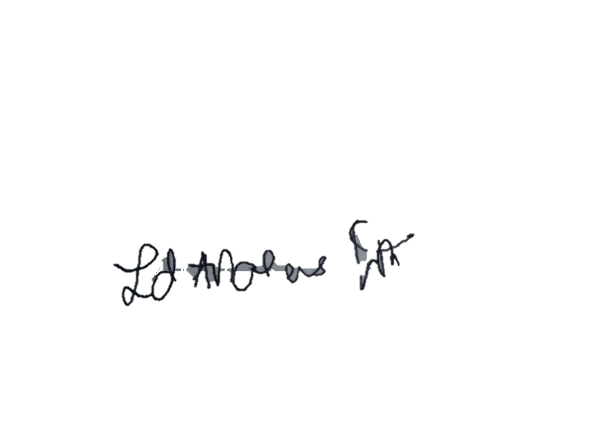None.___________________________________________________________________________________________________________________________________________________________________________________________________________________________________________________________________________________

**CERTIFICATION**

**I can certify to the best of my knowledge that all information contained in this form are true and correct.**

**Submitted by:/February, 2022**

**LOYLYN DE AMOR D. DALAS**

**Signature over printed name/Date**

**CERTIFICATION**

**I can certify to the best of my knowledge that all information contained in this form are true and correct.**

**CERTIFICATION**

**I can certify to the best of my knowledge that all information contained in this form are true and correct.**

**CERTIFICATION**

**I can certify to the best of my knowledge that all information contained in this form are true and correct.**

**CERTIFICATION**

**I can certify to the best of my knowledge that all information contained in this form are true and correct.**